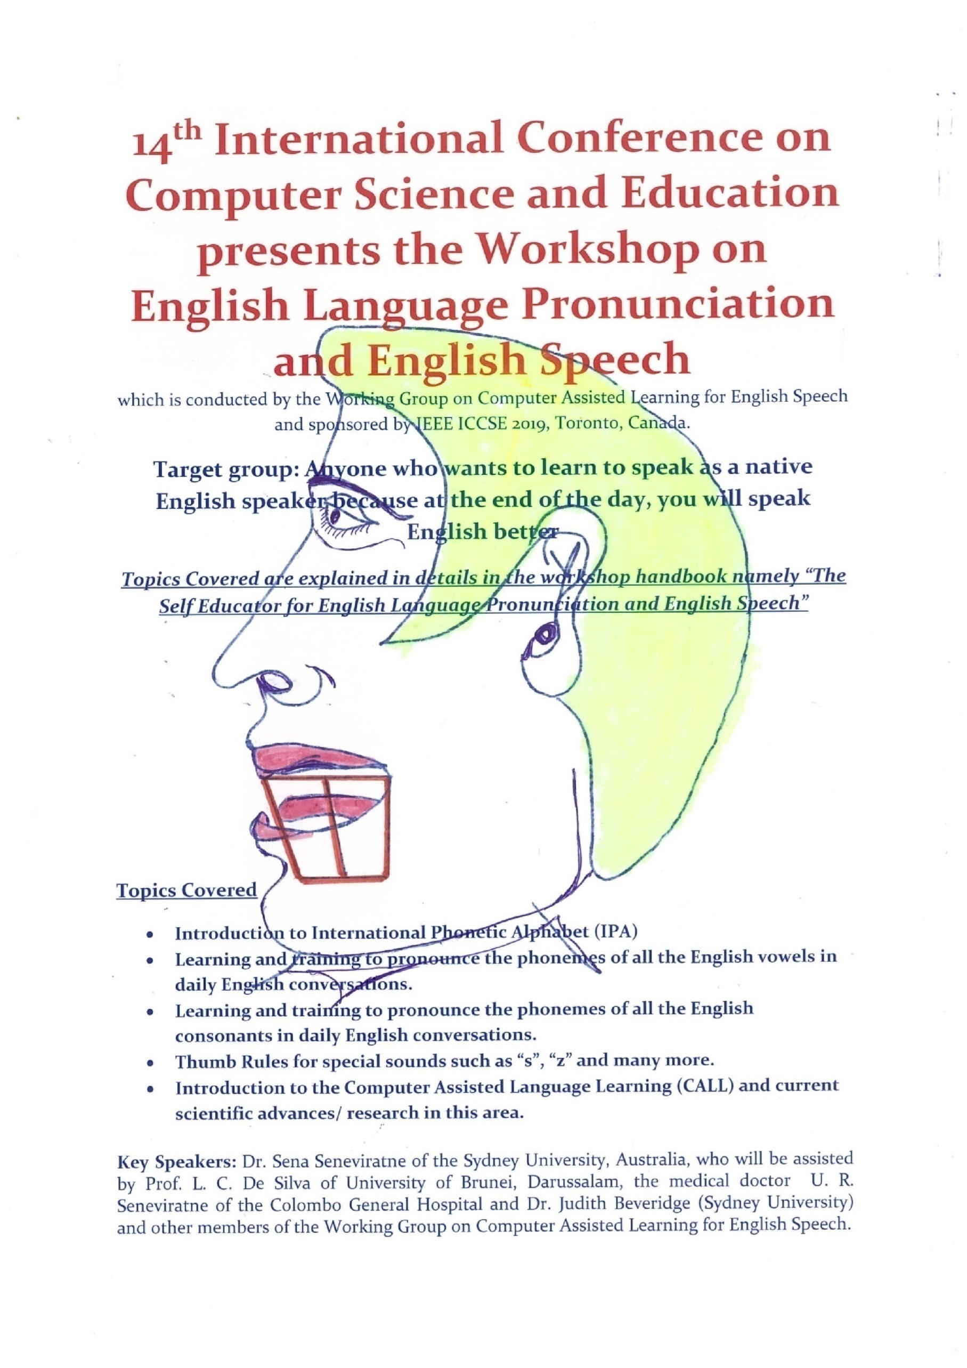
All the Participants should bring the following items along with them to the workshop:
- Hand held device such as I Phone or Smartphone, tablet or Laptop.
- A Small hand held Mirror
Key Speakers: Dr. Sena Seneviratne, Prof. L. C. De Silva and Mr. Noel Wijesingha who will be assisted by Dr. Judith Beveridge, Dr. U. R. Seneviratne and Mrs. Daisy Herft
Bio data of the key speakers

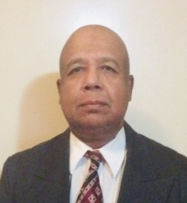

Dr. Sena Seneviratne has received his Ph.D. in the fields of Distributed and High-performance computing from the University of Sydney, Australia in 2009. While continuing his research in the same field, he is researching on the development of software tools for Computer Assisted Language Learning (CALL), using AI and ML techniques.

Since his graduation, Sena has been serving as a Research Associate in the School of Information and Electrical Engineering, Sydney University. He is a visiting researcher in the school of Computer Science and Engineering, Melbourne University with the sponsorship of Directware Ltd Melbourne. He is the primary author of more than 50 conference papers, journal papers, book chapters and English literature collections. Since his graduation, he has been a reviewer for several international journals including Elsevier Journal of Future Generation Computer Systems (FGCS) and Journal of Cluster Computers.

He is the author of 6 books of English Poetry and a collection of short stories that were published in Australia. His latest book namely “Verses of the Silk Road” is currently being printed by the Minuteman Press, Melbourne Australia. He also holds a Master of English Literature degree from the Sydney University.

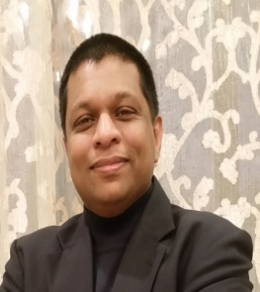

Mr Noel Wijesingha lives in Toronto and leads Sciteqsoft Inc. that provides Information Technology services to North American FORTUNE 200 companies. His research interests are in Artificial Intelligence and machine Learning; use of AI/ ML in management information and decision support systems in retail and telecommunication industry. Noel is a Doctoral Candidate of Business Administration at Chapman Graduate School, Florida International University, MIAMI, FL 33199. He had previously completed his Master of Software Systems at University of St. Thomas, ST. Paul, MN 55105, USA, and MBA at Mike Ilitch School of Business, Wayne State University, Detroit, MI 48202 USA.
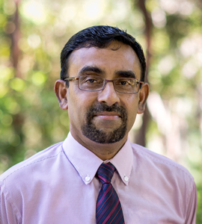

Professor Liyanage C De Silva obtained BSc Eng (Hons) degree from the University of Moratuwa Sri Lanka in 1985, MPhil degree from The Open University of Sri Lanka in 1989, MEng and PhD degrees from the University of Tokyo, Japan in 1992 and 1995 respectively. He was with the University of Tokyo, Japan, from 1989 to 1995. From April 1995 to March 1997 he pursued his postdoctoral research as a Post-Doctoral researcher at ATR (Advanced Telecommunication Research) Laboratories, Kyoto, Japan. In March 1997 he joined The National University of Singapore as a Lecturer where he was an Assistant Professor till June 2003. He was with the Massey University, New Zealand from 2003 to 2007 as a Senior Lecturer. He joined University of Brunei Darussalam in 2007 as an Associate Professor and currently he is a Professor of Engineering and the Dean of the Faculty of Integrated Technologies http://fit.ubd.edu.bn at the University of Brunei Darussalam.

Liyanage’s current research interests are IoT (internet of Things), Image and Speech Signal Processing, Information theory (source coding), Computer Vision, Data Analytics Pattern recognition and understanding (bio-metric identification) Smart Homes and Smart Sensors (Smart environments for security, eldercare and energy efficiency, Smart Grid), Multimedia signal processing (Emotion Recognition), Digital Electronics. He has over 30 years of postgraduate experience in various levels in his career in the Asia Pacific region. Liyanage has published over 170 technical papers in these areas in international conferences, journals and Japanese national conventions and holds one Japanese national patent, which was successfully sold to Sony Corporation Japan for commercial utilization. He also holds 3 US, and 1 Brunei patents with several patents pending. Liyanage’s works have been cited as one of the pioneering works in the bimodal (audio and video signal based) emotion recognition by many researchers. His papers so far have been cited by more than 3000 times (according to scholar.google.com) with an h-index of 21. He is a Senior Member of IEEE (USA).

